Name: Mrinalli S
Reg.No: 192411174

Exp.No.03 Water Jug Problem
14.07.26

Aim:
To write a Python program to solve the Water Jug Problem using Breadth-First Search (BFS).

Algorithm:
- Read the capacities of the two jugs and the target amount.
- Start with both jugs empty (0,0).
- Generate all possible states (fill, empty, pour).
- Use BFS to explore states.
- Stop when the target amount is obtained. Display the solution path.

Program:
from collections import deque
def waterjug(a, b, target):
q = deque([(0, 0)])
visited = {(0, 0)}
while q:
x, y = q.popleft()
print((x, y))
if x == target or y == target:
return
states = [
(a, y), (x, b), (0, y), (x, 0),
(max(0, x-(b-y)), min(b, x+y)),
(min(a, x+y), max(0, y-(a-x)))
]
for s in states:
if s not in visited:
visited.add(s)
q.append(s)
a = int(input("Enter capacity of Jug1: "))
b = int(input("Enter capacity of Jug2: "))
target = int(input("Enter target amount: "))
waterjug(a, b, target)
Input:
Enter capacity of Jug1: 4
Enter capacity of Jug2: 3
Enter target amount: 2
Output:
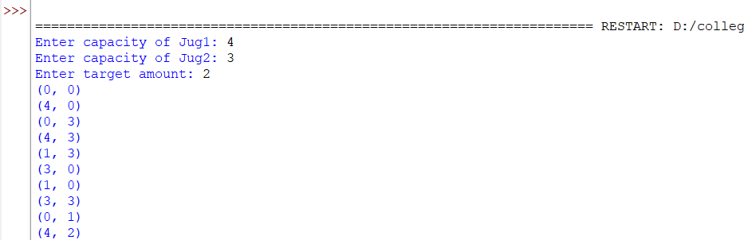

Result:
Thus, the Python program to solve the Water Jug Problem using Breadth-First Search (BFS) was implemented successfully.

